*ECE 445 Senior Design*

*Design Document*

**Electronic Page Turner**

**Team No. 7**

Adia Radecka

(aradec2@illinois.edu)

Alyssa Bradshaw

(akb5@illinois.edu)

Javi Cardenas

(jcarde28@illinois.edu)

**TA:** Raman Singh

***Professor:*** Viktor Gruev

March 31, 2023

**Table of Contents**

**1. Introduction**2

1.1 Problem 2

1.2 Solution 3

1.3 High-Level Requirements 3

**2. Design**6

2.1 Block Diagram 6

2.2 Subsystem Overview 6

2.2.1 Power Subsystem 6

2.2.2 Control & Sensor Subsystem 7

2.2.3 Actuation Subsystem 8

2.3 Subsystem Requirements 9

2.2.1 Power Subsystem 9

2.2.2 Control & Sensor Subsystem 9

2.2.3 Actuation Subsystem 9

2.4 Tolerance Analysis 9

**3. Cost & Schedule**10

3.1 Cost Analysis 10

3.2 Schedule 11

**4. Ethics & Safety**13

4.1 Ethics 13

4.2 Safety 13

**5. References**14

# Introduction

## 1.1 Problem

When reading a book, manual page-turning is a crucial requirement. This simple task can inconvenience those wishing to multitask while reading. A prime example occurs when a musician must stop playing their instrument to turn the sheet music when practicing or performing music. Another example is when cooking and using a cookbook; one may not have free or clean hands to turn the pages. Furthermore, a group to consider is those with disabilities who cannot physically turn a book's pages [1]. These are just a few examples of electronic page-turners’ usefulness, but not many exist. Those that do are generally expensive and typically designed for electronic tablet reading. Another issue with existing page-turners for physical books is that they are made for a limited number of pages and can only turn them in one direction. They also require a lengthy setup to attach each page to the device, which is an issue for those wanting to use a book with more pages than the device can handle.

## 1.2 Solution

To solve this problem, our team aims to create a hands-free electronic page-turner that functions with a foot pedal. The device uses two foot pedal switches to turn a page forward or backward. When the foot pedal is pressed, the control system communicates with the motors to start turning a page. A rubber tip attached to the end of a motor is used to lift a single page at a time. A rod connected to another motor will sweep underneath the raised page, causing it to turn to the next page. Our solution is unique because the device does not require extensive setup and can go through all the pages in a physical book in both directions.

## 1.3 Visual Aid

We provide a pictorial representation of our solution in Figure 1. The main components attached to the book stand will be the motors and a Liquid Crystal Display (LCD).

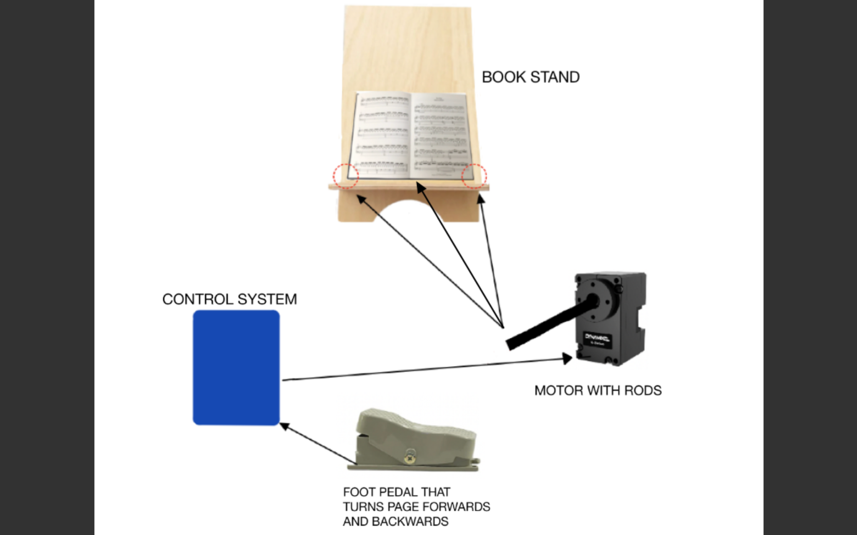

Figure 1: Visual Aid

## 1.4 High-Level Requirements

For our solution to be considered successful, it must achieve the following three goals:

* The device must be able to turn one page within 5 seconds ± 2 seconds. This motion should be repeatable for turning a page backward.
* The device must be able to turn at least ten consecutive pages, with 95% ± 5% accuracy, and take at most 1 minute ± 10 seconds when the foot pedal is pressed consecutively.
* The device must be able to store the total number of pages turned in a single sitting, with 95% ± 5% accuracy, and display this information to the reader.

# Design

## 2.1 Physical Design

Figure 2: Physical Design

This physical design consists of two foot pedal switches, three servo motors, a physical stand to hold the book, a PCB, and an LCD. The input to our device is two foot pedals, and the physical page-turning and LCD act as the output. The LCD keeps track of the number of pages turned forward. The system uses a 5V wall-power adapter to power all its components. The PCB comprises the microcontroller and headers to connect the pedals, motors, and LCD. Two servo motors with rods containing rubber tips at their ends must be located by the corners of the book stand to raise a single page vertically. The center servo motor includes a long rod to sweep underneath the raised page.

## 2.2 Block Diagram

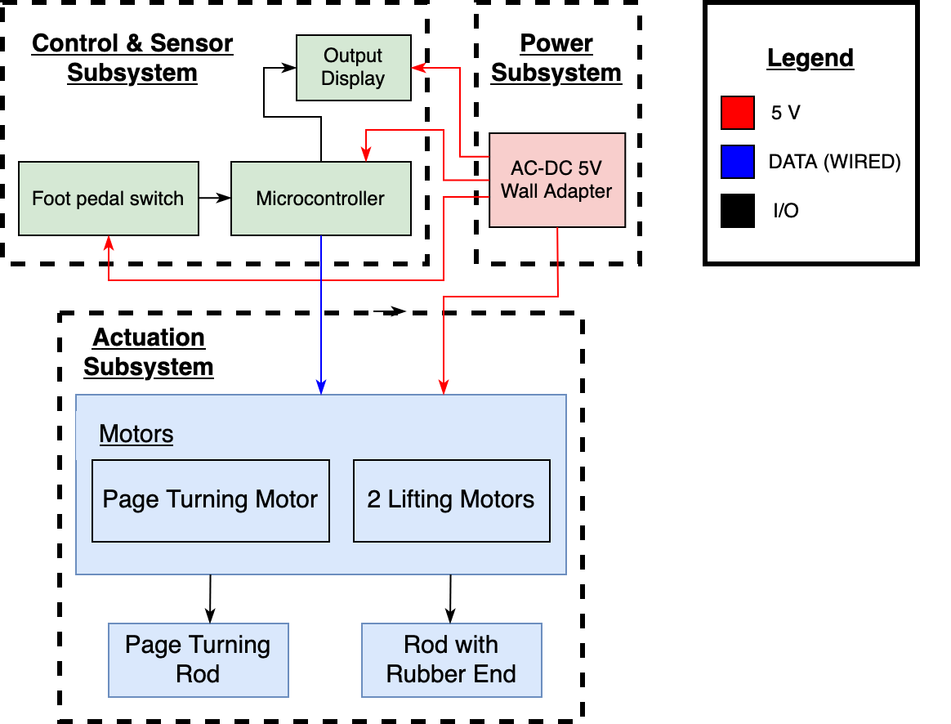

Figure 3: Block Diagram

## 2.3 Subsystem Overview

Our design is divided into three subsystems: Power, Control & Sensor, and Actuation subsystems.

### 2.3.1 Power Subsystem

The power subsystem handles sending power to the rest of the components in the other two subsystems. The power subsystem includes a 5V wall-power adapter that converts from AC-DC, supplying a steady 5V to the rest of the subsystems.

### 2.3.2 Control & Sensor Subsystem

The control and sensor subsystem contains the microcontroller and sensors needed to move the motors. This includes the ATMEGA328P microcontroller, two foot pedal switches, and an LCD. When a foot pedal is pressed, a signal is sent to the microcontroller, determining whether a page is turned forward or backward. The microcontroller then sends a signal to turn on the correct servo motors. The LCD keeps track of the number of pages turned forward.

### 

### 2.3.3 Actuation Subsystem

Two servo motors will lift a single page vertically, the left and right pages, respectively. Attached to the end of each lifting motor will be a short rod with a rubber tip; these motors will be located at the bottom corners of each page. The remaining servo motor will turn the page forward or backward. This page-turning motor will be located by the center of the book stand. Attached to the page-turning motor will be a long rod that rests below the bottom of the book. When the foot pedal is pressed, and the microcontroller processes and sends the signal, the page-turning process will start. First, the lifting motor will move from 0° to 45°, next the center motor will move from 0° to 90°, then the lifting motor will return to its starting position, and finally, the center motor will move to 180° causing the raised page to turn to the next page.

## 2.4 Subsystem Requirements

The requirements for each of our subsystems.

### 2.4.1 Power Subsystem

The power subsystem handles sending power to the rest of the components in the other two subsystems.

| Requirements | Verification |
| --- | --- |
| * Must have a 5V wall adapter that plugs into a wall outlet. * All components must be supplied with 5 V ± 5%, when the devices are idle and when active. | * Use a multimeter to check that the wall adapter’s barrel jack is supplying a steady 5V ± 5%. * While the device is turned on, measure the voltage across each device using an oscilloscope. Repeat this process when a foot pedal is pressed. |

### 2.4.2 Control & Sensor Subsystem

The control and sensor subsystem contains the microcontroller and sensors needed to move the motors. The foot pedal sensor must be able to send a signal when pressed to the microcontroller.The microcontroller must then communicate with the motors to begin turning pages.

| Requirements | Verification |
| --- | --- |
| * When the left foot pedal is pressed, the corresponding motors to turn a page backward should rotate. When the right foot pedal is pressed, the corresponding motors to turn a page forward should rotate. * LCD Display must track the number of pages turned forward. | * Test the situation where the foot pedal is not pressed. Ensure that the motors do not rotate. * Test the situation where the foot pedal is pressed. Ensure that the lifting motors rotate 0°-45°-0° and the center motor rotates 0°-90°-180°. * When a page is turned forward, the count should increase by 1. If a page is turned backward, the count should decrease by 1. |

### 

### 2.4.3 Actuation Subsystem

The actuation subsystem handles the mechanical work of turning the page and includes three servo motors. The motors must successfully lift a page and then turn that page over. This motion must be repeatable for forwards and backwards page turning.

| Requirement | Verification |
| --- | --- |
| * The servo motors must create negligible backwards EMF. * The force of the motors should not be enough to cause tearing or damage to the books pages. | * Use an oscilloscope to plot the voltage of a motor when idle and when active. If the voltage spike is 1V ± 0.5V we can consider the backwards EMF from the motor negligible. Otherwise, we will add more capacitors and diodes to prevent negatively impacting the other hardware in our device. * Using a singular lifting motor, run 10 trials to test how the force and speed required to lift one page. Tune the parameters in software accordingly. * Using the sweeping motor, run 10 trials to test the force and speed required to lift one page. Tune the parameters in software accordingly. The slowest speed required to turn a page will be chosen for safety. |

## 

## 2.5 Tolerance Analysis

A crucial part of our project's success is the motors to lift a single page and the center motor to flip the page. We must consider the thickness of a book and how far along into the book we are for the lifting motors to hold a page vertically. For testing, we will be using a music sheet book with the following dimensions: 9 x 0.24 x 12 inches. The lifting motors must reach low enough to grab the very last page of the book, which would be at 0.0025 inches. We determined that the page must be lifted one inch to provide the sweeping rod attached to the center motor enough space to flip the page. Therefore a singular page must be displaced 45°, with respect to, the book if using a one inch rod to lift the page as shown in Equation 1.

Equation 1: Angular displacement for a 1 in. rod attached to lifting motor

Equation 2: Angular displacement for a 3 in. rod attached to lifting motor

Equation 3: Angular displacement for sweeping rod attached to center motor

Additionally, two of our high-level requirements involve time. More specifically, the time it takes to flip a single page and to turn ten pages consecutively. According to the datasheet for the motors, the maximum torque each can provide is 5.5 kg/cm = 0.053937 Nm, as shown in Equation 4. Ideally, each motor will receive 600 mW of power, as shown in Equation 5. By finding the maximum angular velocity, in Equation 6, the time it takes for each motor to complete its angular displacement can be calculated as shown in Equation 7. This process will ideally take 423.62 ms (2 X 70.603 + 282.41 ms). While these calculations are under ideal conditions, realistically, we can expect the process to take about 1 second. We also have to consider going too fast may cause physical damage to the book’s pages, which we plan to avoid. Furthermore, the time delay for signals from the foot pedal and microcontroller will require additional time. Therefore our given estimate in the high-level requirements is a reasonable baseline.

Equation 4: Maximum torque provided in motor datasheet

Equation 5: Maximum power provided to each motor

Equation 6: Maximum angular velocity for each motor

Equation 7: Time required for each motor to reach their angular displacement

# Cost & Schedule

## 3.1 Cost Analysis

Production of this device is estimated at 30 hours per week over 15 weeks distributed amongst three people. The three of us are electrical engineering majors, and based on our current job offers, the average pay is $40 per hour. Based on this hourly rate, the estimated labor cost for this initial design is $18,000.

Below we have included a table to breakdown the cost of all parts required for the initial design. Based on these numbers we estimate a cost of $129.57 for all required components.

| **Part** | **Part Number** | **Unit Price** | **Quantity** | **Total** |
| --- | --- | --- | --- | --- |
| Microcontroller | ATMEGA328P-PU |  | 1 |  |
| Foot Pedal | n/a | $10.43 | 2 | $20.86 |
| Servo Motor | HS-311 | $14.76 | 3 | $44.28 |
| PCB Manufacture | n/a | $30.00 | 1 | $30.00 |
| On/Off Switch | JS202011CQN | $0.60 | 1 | $0.60 |
| AC to DC Converter | UCC28610DR | $1.65 | 1 | $1.65 |
| Barrel Jack | PJ-102AH | $0.82 | 1 | $0.82 |
| Power Plug | PP3-002A | $1.44 | 1 | $1.44 |
| Linear Regulator | LM117MP | $1.70 | 1 | $1.69 |
| ISP Header | 1597-114020164-ND | $2.80 | 1 | $2.80 |
| 3 Pin Header | WM4201-ND | $0.27 | 3 | $0.81 |
| LCD Display | 2632-C162A-BW-LW65-ND | $6.27 | 1 | $6.27 |
| 10k Resistor | 2197-294-10-RC-ND | $0.15 | 3 | $0.45 |
| 1uF Capacitor | 478-1836-ND | $0.82 | 3 | $2.46 |
| 3 pin MTA100 connector | A19470-ND | $0.23 | 3 | $0.69 |
| 3D Printed Motor Rods | N/a | $1.00 | 3 | $3.00 |
| **Total Cost** | | | | $129.57 |

Table 1: Total Cost of Required Components

## 3.2 Schedule

* Week of 02/20; Week 6

*Design Document, Team Contract, Revise Proposal, Work on PCB Design in office hours, Make design review presentation*

* Week of 02/27; Week 7

*Design Review, PCB Review, pickup stand built by Machine shop, Continue working on PCB design, Pickup all ordered parts*

* Week of 03/06; Week 8

*First round PCB orders, Order PCB parts, Order PCB, Teamwork Evaluation*

* Week of 03/13; Week 9

*Spring Break*

* Week of 03/20; Week 10

*Prototype 1: Solder PCB, Put all mechanical and electrical parts together, debug and review*

* Week of 03/27; Week 11

*Order second PCB if needed, Individual Evaluation, Debug Review*

* Week 0f 04/03; Week 12

*Prototype 2: Debug and review*

* Week of 04/10; Week 13

*Team contract fulfillment*

* Week of 04/17; Week 14

*Mock Demo, review, work on Final Demo and presentation*

* Week of 04/24; Week 15

*Final Demo, Mock Presentation, work on presentation and paper*

* Week of 05/01; Week 16

*Final Presentation, Final Paper*

# 

# Ethics & Safety

## 4.1 Ethics

The IEEE code of ethics lists a few policies that should be considered while working on this project. Policy 1.5 states “to seek, accept, and offer honest criticism of technical work, to acknowledge and correct errors, to be honest and realistic in stating claims or estimates based on available data, and to properly credit the contributions of others''. [2] This policy applies to this project because page-turners are currently available. We will adequately credit any work done on page-turners and build upon those ideas. Additionally, criticism and new ideas will be welcomed so that our project development process is rewarding.

## 4.2 Safety

Although our project is a hands-free device, there is a possibility of injury if any bodily parts interfere with the device while it is in motion. The rods attached to the motors will perform a sweeping action to turn the pages. While there is not enough force to cause severe injury, placing your hand in the way while the rod is in motion may hurt. We need to keep in mind the rod's material and the speed of the motors so that if contact does occur, it will not cause any severe damage. Setting the correct speed is also important to avoid tearing or damage to the pages of the book. If the speed is too fast, the force of the rods can cause damage to the book. To prevent this from occurring, we plan to tune the parameters in the software accordingly. Ideally, the slowest speed that still turns a page will be chosen to avoid any safety issues. Also, if someone has their hands in the way and causes the motor to stall, this will cause the motor to heat up. Although unlikely, this could potentially cause a burn to the individual.

Another potential danger could be from the power subsystem. Although our device does not require high voltage to operate, we will use a wall power adapter which creates the issue of electric shock. Electric shock occurs when current flows through your body. The larger the voltage, the more current there is and the worse the shock could be. An electric shock can occur if you touch the live and neutral wire of the power supply as you become a part of the circuit and allow current to flow through you. It is essential to be mindful of this connection and not to touch the leads of these wires when plugged into the power supply. It is also crucial to ensure none of the equipment is faulty as this can cause electric shock. Faulty equipment includes but is not limited to damaged wires, damaged plugs, broken connections, wet plugs, and plugs with missing prongs[3]. Before using any equipment, our team will take the mandatory high voltage safety training and plan to keep this training in mind as we work on our project to avoid the danger of electric shock. We will also implement the one-hand rule to prevent current from flowing into your body and out the other connection point. We will also check to make sure all equipment is undamaged before use.

# References

[1] “Assistive Technologies for Reading,”ASCD, Dec-2005. [Online]. Available: <https://www.ascd.org/el/articles/assistive-technologies-for-reading>. [Accessed:06-Feb-2023]

[2] “IEEE code of ethics,” IEEE, Jun-2020. [Online]. Available: <https://www.ieee.org/about/corporate/governance/p7-8.html>. [Accessed:06-Feb-2023].

[3] C. C. for O. H. and S. Government of Canada, “The Young Workers Zone : Teaching Tools : Physical hazards: Electrical,” *The Young Workers Zone : Teaching Tools : Physical Hazards: Electrical*, 12-Jul-2010. [Online]. Available: <https://www.ccohs.ca/teach_tools/phys_hazards/electrical.html>. [Accessed: 23-Feb-2023].